Research Title in English (Times New Roman, Font Size 18, Bold)
Author's Full Name¹, Author's Full Name² ¹Department, Faculty, University, City, Country, Email or ORCID
²Department, Faculty, University, City, Country, Email or ORCID
Abstract:
The abstract should provide a concise summary of the research, not exceeding 250 words. It must include the study’s background, problem, objectives, methodology, key results, and main conclusions or scientific implications. The abstract must be written in clear and precise scientific language, free from abbreviations, citations, or tables, enabling the reader to grasp the research core without referring to the full text. Font: Times New Roman, Size 12, Regular. Line spacing: Single.
Keywords: Three to five words or phrases, separated by commas.
Research Title in Arabic (Simplified Arabic, 16, Bold) (Optional for international participants, required for local participants)
عنوان البحث باللغة العربية (حجم الخط 16، غامق، Simplified Arabic)
اسم المؤلف الأول ثلاثي¹، اسم المؤلف الثاني ثلاثي²
¹ القسم، الكلية، الجامعة، المدينة، الدولة، البريد الإلكتروني أو ORCID
² القسم، الكلية، الجامعة، المدينة، الدولة، البريد الإلكتروني أو ORCID
ملخص
يقدّم الملخص عرضاً موجزاً لمحتوى البحث بما لا يزيد عن 250 كلمة، ويتضمن بإيجاز خلفية الدراسة وأهميتها، ومشكلتها وأهدافها، والمنهجية المتبعة، وأبرز النتائج ، وأهم الاستنتاجات أو الدلالات العلمية. يُكتب الملخص بلغة علمية واضحة ودقيقة، خالية من الاختصارات أو الاستشهادات أو الجداول، وبما يمكن القارئ من تكوين فكرة شاملة عن البحث دون الرجوع إلى النص الكامل، و يكتب الملخص بخط عادي (حجم 12 Simplified Arabic)، و يكون تباعد الأسطر مفرد.
الكلمات المفتاحية: لاتقل عن ثلاث كلمات، وتُفصل بينها بفواصل.

Disclosure of Artificial Intelligence (AI) Tools: The authors declare the use of (Name of the Tool and Version/Model) during the (Specify Stage: data analysis, language editing, programming) stage, representing approximately (Percentage or nature of the role). The authors bear full responsibility for the scientific integrity and accuracy of the generated outputs.
1. Introduction
Research papers in English must be typed in Times New Roman. Main headings should be in Font Size 16 (Bold), and subheadings in Font Size 14 (Bold). The body text should be in Font Size 14 (Regular), with line spacing of (1.15). Use justified paragraph alignment to ensure a clean layout. Page margins must be set to 2.5 cm on all sides (Top, Bottom, Left, and Right).
.2 Methodology and Tools
This section outlines the research approach, methodology, and tools (including AI applications or models) employed to conduct the study.
3. Results (Tables, Figures, and Equations)
Results should be presented objectively without interpretation. Tables and figures must be cited in the text before their appearance. A. Tables
Tables should be numbered sequentially as they appear in the text. The table title, including the number, must be placed above the table, centered, and typed in Font Size 12 (Bold). The first row (Header) should be in Font Size 11(Bold), while the internal data should be in Font Size 11 (Regular). Tables must be in an "Open Style" (no vertical lines), as shown in Table (1)
Table (1): Summary of AI Tools and their Applications in the Current Research
Research Phase | AI Tool | Nature of Use and Function
Literature Review | Perplexity AI / Consensus | Identifying modern scientific sources and summarizing previous results.
Data Analysis | Python (Pandas & Scikit-learn) | Building predictive models and automated big data classification.
Manuscript Editing | Grammarly / ChatGPT | Improving linguistic quality and grammatical proofreading.

It is evident from Table (1) that the study relied on the principle of integration between human effort and AI technologies across various research stages. Tools such as (Perplexity AI / Consensus) were utilized to enhance the efficiency of the literature review, while advanced (Python)libraries were used in the analytical phase to build accurate predictive models. Furthermore, linguistic editing tools ensured high-quality academic phrasing. These results collectively indicate that the technology served as a supportive tool to boost research efficiency, while full scientific responsibility for the verification and interpretation of results remained with the human researcher.
B. Figures and Charts
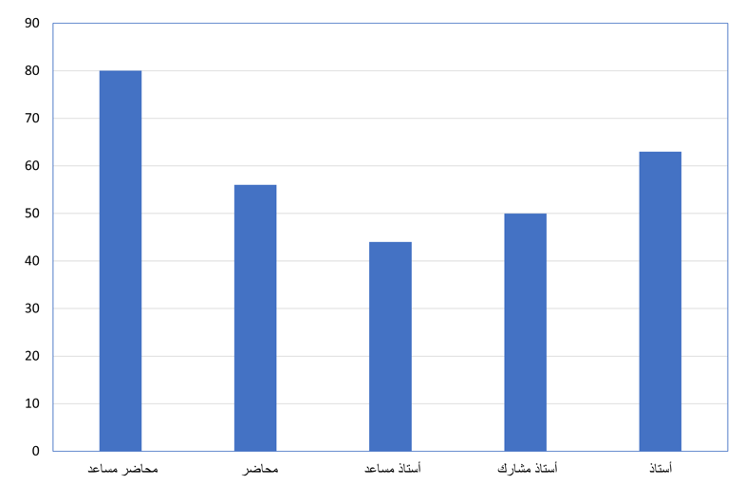
Figures and charts should be numbered sequentially. The figure title must be placed below the figure, centered, in Font Size 12 (Bold). Figures must be of high resolution and clarity, as shown in Figure (1).

Figure (1): Distribution of Sample Size according to Academic Rank
From Figure (1), it is clear that the largest number of participants were Assistant Lecturers, followed by Professors.

C. Equations
Equations should be created using the Word Equation Editor in Font Size 14. Equations should be centered, with their numbers placed in parentheses on the right side of the page as follows:
A=b∗x+c | (1)

After formulating the equation, the variables must be defined. For example: A refers to the dependent variable, and x to the independent variable.
4. Discussion
This section involves interpreting the results and linking them to previous studies, clarifying points of agreement and disagreement supported by robust scientific evidence, and highlighting the study's limitations.
5. Conclusion
The study concludes by presenting a set of findings and recommendations that contribute to enriching both the theoretical and practical knowledge in the field and opening new avenues for future research.

Ethical Approval: Ethical standards were followed; necessary approvals and i
nformed consents were obtained [Approval No: .......].
Scientific Integrity: Authors declare the originality of the work, free from any form of plagiarism, and transparency in reporting results.
Conflict of Interest: The authors declare no conflicts of interest. Funding: [This research was funded by: .............] OR [No external funding was received].
Data Availability: [Data available upon request] OR [Link: .............].

6. References
All references cited in the text must adhere to the Harvard Reference System, which employs the (Author's Last Name, Year) format. To ensure accuracy and consistency, researchers are strongly encouraged to manage their citations and final reference list using professional software such as Mendeley, EndNote, or Zotero (refer to Appendix 1 for detailed instructions on the digital method)."
Indirect Citation (Paraphrasing):
1. Manual Method:
Single Author: (Al-Sharif, 2022) or (Smith, 2020).
Two Authors: (Ali & Hassan, 2023).
Three or More: (Al-Trabulsi et al., 2021) or (Brown et al., 2022).
Official Report: (Ministry of Education, 2023) or (World Bank, 2023).
2. Digital Method (Recommended):
Use software like (Mendeley, Zotero, or EndNote) via the "Insert Citation" feature, (Refer to Appendix 1 for digital insertion steps).
Styles of Indirect Citation:
- Narrative Citation: Abdulrahman (2020) stated that scientific research methods represent the basis for building knowledge.
- Parenthetical Citation: Scientific research methods are the cornerstone of building knowledge (Abdulrahman, 2020).
Direct Citation:
Text must be enclosed in " ". Cite using the same rules above but add the page number: (Smith, 2024, p. 15).
Note: To add page numbers using digital software, please follow the steps in Appendix 1.
Final Reference List: The list should appear at the end of the research, in Font Size 12 (Regular), Times New Roman, with Single spacing.
Guidelines for Manual Reference Listing:
Ensure all data is accurate (Author's name, Year, Title, Publisher, Location, or URL).
References must be listed alphabetically by the first author's last name. Titles should be in Italics.
For multiple works by the same author, sort by year (oldest to newest). If the year is the same, use letters (a, b, c) after the year:
- Ahmed, M. (2020a). Applied Research Methodologies. Cairo: Dar Al-Fikr.
- Ahmed, M. (2020b). Statistical Analysis Techniques. Cairo: Dar Al-Maarefa.
Manual Citation Formats for Various Sources:
1. Books Format:
Surname, Initial. (Year). Title of the Book. Location: Publisher.
Example:
Abdulrahman, M. (2020). Research Methods in Education and Psychology. Cairo: Dar Al-Fikr Al-Arabi.
2. Journal Articles Format:
Surname, Initial. (Year). "Title of the Article", Journal Name, Vol(Issue), pp. Pages.
Example:
Benisa, M. and Ashour, F. (2021). "The impact of motivation on the performance of employees in educational institutions," Journal of Human Sciences, 15(2), pp. 45–67.
3. Conference Papers Format:
Surname, Initial. (Year). "Title of the Paper", in: Name of the Conference, Location, pp. Pages.
Example:
Al-Qadri, M. (2022). "The impact of modern technology use in higher education", in: National Conference on Education and Technology, Tripoli, pp. 15–27.
4. Theses and Dissertations (Unpublished) Format: Surname, Initial. (Year). Title of the Thesis (Unpublished master's/doctoral thesis). University, Country.
Example:
Al-Abeidi, S. (2022). The role of administration in improving the quality education in Libya (Unpublished master's thesis). University of Tripoli, Libya.
5. Websites Format:
Author or Entity. (Year or last update). Title of the page. [Online]. Available at: URL [Accessed Date].
Example:
Ministry of Higher Education and Scientific Research. (2023). Annual report on Libyan universities. [Online]. Available at: https://www.higheredu.gov.ly [Accessed: 5 November 2025].
Sample Reference List:
Al-Abeidi, S. (2022). The role of administration in improving the quality education in Libya (Unpublished master's thesis). University of Tripoli, Libya.
Abdulrahman, M. (2020). Research methods in education and psychology. Cairo: Dar Al Fikr Al Arabi.
Benisa, M. and Ashour, F. (2021). "The impact of motivation on the performance of employees in educational institutions," Journal of Human Sciences, 15(2), pp. 45–67.
Al-Qadri, M. (2022). "The impact of modern technology use in higher education", in: National Conference on Education and Technology, Tripoli, pp. 15–27.

Note: Authors' names should be written without academic titles.

Appendix 1:
Using Digital Software for Reference Management
A. Inserting Indirect Citations:
When using digital software (Mendeley, Zotero, or EndNote), place the cursor where you want the citation, click the (Insert Citation) feature within the Word "References" tab, and the software will format it automatically.
B. Inserting Direct Citations (Adding Page Numbers):
- Insert the reference using the Insert Citation feature.
- Once the citation appears in Word, click on it.
- The software window (Mendeley or Zotero) will open; click on the reference within that window and type the page number in the (Page) field.
- Click (OK), and the software will automatically add the page number and format it according to the Harvard system.
C. Generating the Final Reference List (Bibliography):
After finishing the research and citing all sources in the text, follow these steps to insert the final list:
- Go to the end of the research paper (the "References" section).
- From the (References) tab in Word, specifically within the used software tool (Mendeley or Zotero), click on the (Insert Bibliography) feature.
- The software will automatically pull all cited references from the text, arrange them alphabetically, and format them according to the Harvard system in one step.

